Thursday, November 22, 2018

CHAPTER 4

P.P.4.1

12 Ω

8 Ω

i₂

+

v_{o}

−

4 Ω

i₁

i_{S}

By current division,
When i_{s} = 30 A, 40 V
When i_{s} = 45 A, 60 V

P.P.4.2

12 Ω

8 Ω

v₁

+

v_{o}

−

5 Ω

V_{S} = 30 V

+
−

i

Let v_{o} = 1 volt. Then i = and
giving v_{s} = 2.5V.

If v_{s} = 40V, then v₀ = (40/2.5)(1) = 16 V
P.P.4.3 Let v₀ = v₁ + v₂, where v₁ and v₂ are contributions to the 12–V and 5–A sources respectively.

5 Ω

2 Ω

i

12 V

+
−

3 Ω

+

v₁

−

(a)

5 Ω

i₂

+

v₂

−

2 Ω

i₁

5 A

(b)

3 Ω

To get v₁, consider the circuit in Fig. (a).

(2 + 3 + 5)i – 12 = 0 or i = 12/(10) = 1.2 A
v₁ = 2i = 2.4 V

To get v₂, consider the circuit in Fig. (b).

Since the resistors are equal (5 = 2 + 3) then the current divides equally and
i₁ = i₂ = 5/2 = 2.5 and v₂ = 2i₂ = 5 V

Thus,
v = v₁ + v₂ = 2.4 + 5 = 7.4 V

P.P.4.4 Let v_{x} = v₁ + v₂, where v₁ and v₂ are due to the 25-V and 5-A sources respectively.

20 Ω

v₁

4 Ω

25 V

+
−

(a)

0.1v₁

4 Ω

5 A

(b)

20 Ω

0.1v₂

v₂

To obtain v₁, consider Fig. (a).

– or 0.2v₁ = 25/20 = 1.25 or v₁ = 6.25 V

For v₂, consider Fig. (b).

–5 – 0.1v₂ + or 0.2v₂ = 5 or v₂ = 25 V

v_{x} = v₁ + v₂ = 31.25 V

P.P.4.5 Let i = i₁ + i₂ + i₃

where i₁, i₂, and i₃ are contributions due to the 8-V, 2-A, and 6-V sources respectively.

2 A

6 Ω

2 Ω

8 Ω

i₂

(b)

6 Ω

8 V

+
−

2 Ω

8 Ω

i₁

(a)

6 Ω

6 V

+
−

2 Ω

8 Ω

i₃

(c)

For i₁, consider Fig. (a),
For i₂, consider Fig. (b). By current division,

For i₃, consider Fig. (c),
Thus, i = i₁ + i₂ + i₃ = 0.5 + 0.25 – 0.375 = 375 mA

P.P.4.6 Combining the 6-Ω and 3-Ω resistors in parallel gives . Adding the 1-Ω and 4-Ω resistors in series gives 1 + 4 = 5Ω. Transforming the left current source in parallel with the 2-Ω resistor gives the equivalent circuit as shown in Fig. (a).

10V

+
−

2 Ω

7 Ω
− +

(a)

5 Ω

3A

5 V

i_{o}

2 Ω

7.5A

7 Ω

(b)

5 Ω

3A

i_{o}

(10/7) Ω

10.5A

7 Ω

(c)

i_{o}

Adding the 10-V and 5-V voltage sources gives a 15-V voltage source. Transforming the 15-V voltage source in series with the 2-Ω resistor gives the equivalent circuit in Fig. (b). Combining the two current sources and the 2-Ω and 5-Ω resistors leads to the circuit in Fig. (c). Using circuit division,

= 1.78 A

P.P.4.7 We transform the dependent voltage source as shown in Fig. (a). We combine the two current sources in Fig. (a) to obtain Fig. (b). By the current division principle,

i_{x} = 7.059 mA

10 Ω

24m A

5 Ω

(a)

i_{x}

0.4i_{x}

10 Ω

4 – 0.4i_{x} A

5 Ω

(b)

i_{x}

P.P.4.8 To find R_{Th}, consider the circuit in Fig. (a).

6 Ω

4 Ω

(a)

R_{Th}

6 Ω

2 A

6 Ω

4 Ω

(b)

6 Ω

2 A

+

V_{Th}

−

3 Ω
To find V_{Th}, we use source transformations as shown in Fig. (b) and (c).

6 Ω

6 Ω

24 V

+
−

(c)

4 Ω

+

V_{Th}

−

Using current division in Fig. (c),

6 V

1.5 A

P.P.4.9 To find V_{Th}, consider the circuit in Fig. (a).

6 V

5 Ω

I_{x}

4 Ω

+
−

(a)

1.5I_{x}

i₁

i₂

i₁

i₂

3 Ω

o

+

V_{Th}

−

b

a

1.5I_{x}

1 V

+
−

3 Ω

0.5I_{x}

5 Ω

(b)

a

b

4 Ω

I_{x}

i

I_{x} = i₂
i₂ - i₁ = 1.5I_{x} = 1.5i₂ i₂ = -2i₁ (1)

For the supermesh, -6 + 5i₁ + 7i₂ = 0 (2)

From (1) and (2), i₂ = 4/(3)A

V_{Th} = 4i₂ = 5.333V

To find R_{Th}, consider the circuit in Fig. (b). Applying KVL around the outer loop,

I_{x} = -2
= 444.4 mΩ

P.P.4.10 Since there are no independent sources, V_{Th} = 0 V.

15 Ω

(a)

5 Ω

i_{o}

10 Ω

4v_{x}
+ −

+

v_{x}

−

+

v_{o}

−

i

(b)

5 Ω

15i_{o}

10 Ω

4v_{x}
+ −

+

v_{x}

−

+

v_{o}

−

15 Ω

+
–

To find R_{Th}, consider Fig.(a). Using source transformation, the circuit is transformed to that in Fig. (b). Applying KVL, ).

But v_{x} = -5i. Hence, 30i - 20i + 15i_{o} = 0 10i = -15i_{o}
v_{o} = (15i + 15i_{o}) = 15(-1.5i_{o} + i_{o}) = -7.5i_{o}
R_{Th} = v_{o}/(i_{o}) = –7.5 Ω It needs to be noted that this negative resistance indicates we must have an active source (a dependent source).

P.P.4.11

3 Ω

6 Ω

(a)

R_{N}

3 Ω

5A

3 Ω

(b)

3 Ω

4A

I_{N}

From Fig. (a), R_{N} = 3 Ω

From Fig. (b), I_{N} = 4.5 A

P.P.4.12

2 Ω

(a)

6 Ω

2v_{x}
+ −

+

v_{x}

−

+

v_{x}

−

1V

+
−

i_{x}

i

2 Ω

(b)

6 Ω

10 A

2v_{x}
+ −

+

v_{x}

−

I_{sc}

To get R_{N} consider the circuit in Fig. (a). Applying KVL,
But v_{x} = 1, 6i_{x} = 3 i_{x} = 0.5
1 Ω

To find I_{N}, consider the circuit in Fig. (b). Because the 2Ω resistor is shorted, v_{x} = 0 and the dependent source is inactive. Hence, I_{N} = i_{sc} = 10 A.

P.P.4.13 We first need to find R_{Th} and V_{Th}. To find R_{Th}, we consider the circuit in
Fig. (a).

2 Ω

4 Ω

1 V

+
−

(a)

1 Ω

3v_{x}

+

−

i

v₀

+ −

v_{x}

9 V

+
−

i_{o}

1 Ω

+

V_{Th}

−

+

−

3v_{x}

2 Ω
+ −

v_{x}

4 Ω

(b)

Applying KCL at the top node gives

But v_{x} = -v_{o}. Hence

v_{o} = 1/(19)
R_{Th} = 1/i = 38/(9) = 4.222 Ω

To find V_{Th}, consider the circuit in Fig. (b),

-9 + 2i_{o} + i_{o} + 3v_{x} = 0

But v_{x} = 2i_{o}. Hence,

9 = 3i_{o} + 6i_{o} = 9i_{o} i_{o} = 1A

V_{Th} = 9 – 2i_{o} = 7V

R_{L} = R_{Th} = 4.222 Ω

2.901 mW

P.P.4.14 We will use PSpice to find V_{oc} and I_{sc} which then can be used to find V_{Th} and R_{th}.
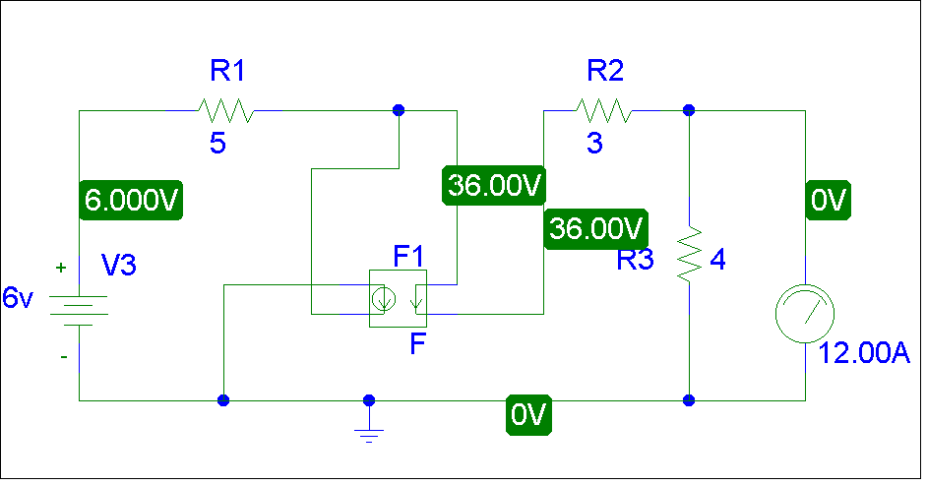
Clearly I_{sc} = 12 A

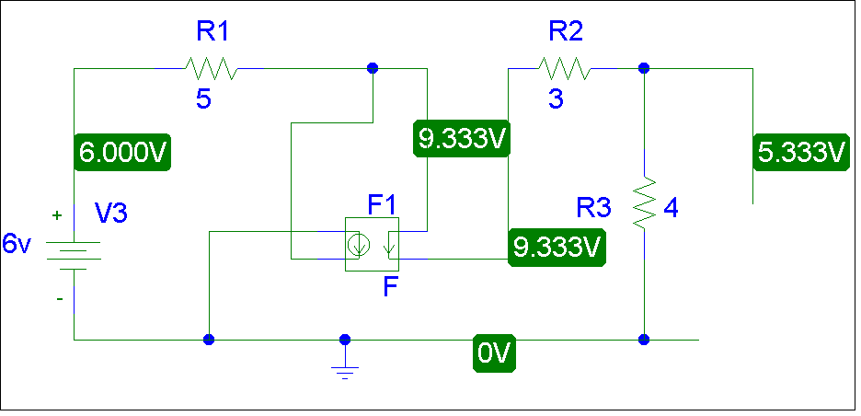

Clearly V_{Th} = I_{oc} = 5.333 V. R_{Th} = Voc/Isc = 5.333/12 = 444.4 mΩ.

P.P.4.15 The schematic is the same as that in Fig. 4.56 except that the 1-kΩ resistor is replaced by 2-kΩ resistor. The plot of the power absorbed by R_{L} is shown in the figure below. From the plot, it is clear that the maximum power occurs when R_{L} = 2 kΩ and it is 125 μW.

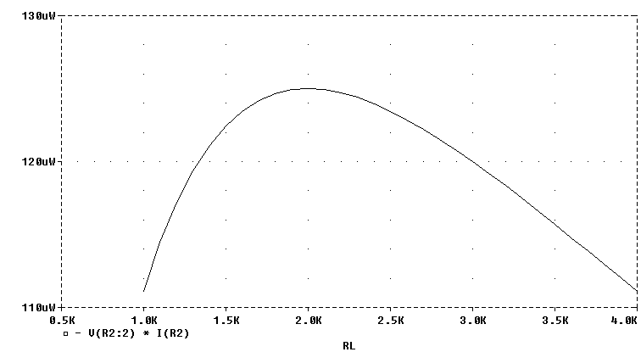

P.P.4.16 V_{Th} = 9 V,

+

V_{L}

−

9 V

+
−

2.5 Ω

10 Ω

7.2 V

P.P.4.17 R₁ = R₃ = 1 kΩ, R₂ = 3.2 kΩ
3.2 kΩ

P.P.4.18 We first find R_{Th} and V_{Th}. To get R_{Th}, consider the circuit in Fig. (a).

= 12 + 24 = 36 Ω

30 Ω

40 Ω

60 Ω

20 Ω
+ −

V_{Th}
+
−
+
−

10 V

v₂

v₁
+
−

(b)

a

b

30 Ω

40 Ω

60 Ω

20 Ω

(a)

R_{Th}

b

a

To find V_{Th}, we use Fig. (b). Using voltage division,

But v_{Th} = v₁ - v₂ = 9.6 - 6.4 = 32 V

64 mA

